Review of Limits
A Puzzle by David Pleacher

Directions: Solve each of the 17 problems on limits and find its matching answer in the column at the right. Use the word at the right of the answer to decode the message below.

MATCHING
___ 1. 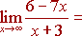 None of the answers below: WHERE

___ 2. 4x AND

___ 3. 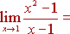 BE

___ 4. 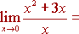 -11 WATCH

___ 5. 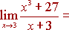 -9 THREE

___ 6. 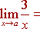 -7 GROUPS

___ 7. 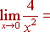 -6 PEOPLE

___ 8. -1 WATCHES

___ 9. 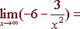 0 HAPPENED

___ 10. 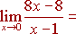 2 MAKE

___ 11. 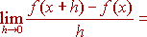 3 THINGS
If
___ 12. 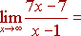 4 THOSE

___ 13. 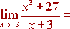 5 WHAT

___ 14. 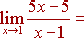 6 CAN

___ 15. 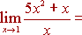 7 DIVIDED

___ 16. 8 HAPPEN

___ 17. 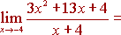 9 WONDER

27 INTO

35 WHY

WHO

NOW, Decode the secret message by placing the corresponding word for each problem number in the blank spaces below:

______ ______ ______ ______ ______ ______ ______:
9 15 6 12 13 16 1

______ ______ ______ ______ ______
2 8 3 4 10

______ ______ ______ ______ ______
2 8 17 4 10

______ ______ ______ ______ ______ ______
11 2 8 5 14 7

