**Parabola Reflection Property**

**Given: the parabola y2 = 4px, F is the focus, QA is tangent to y2 = 4px at Q.**

**Prove: at any point Q, angle 1 = angle 3**

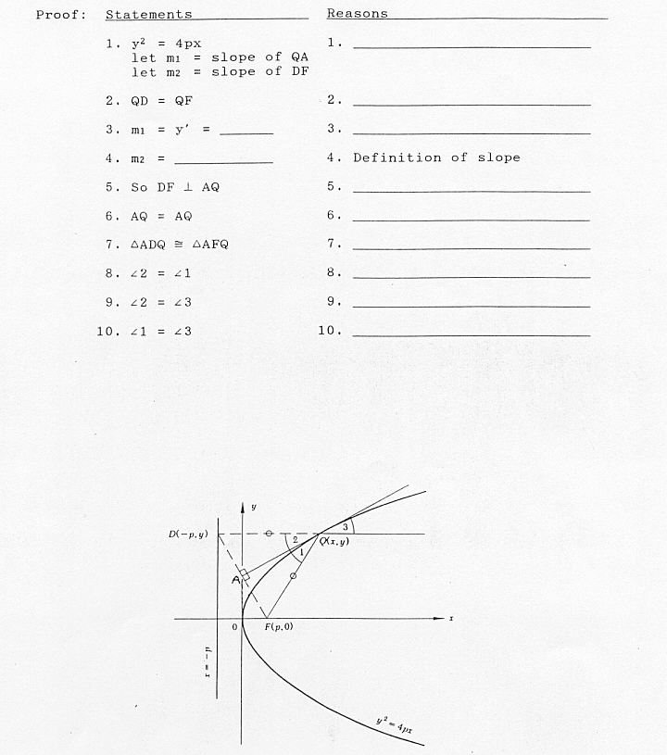

**Elliptical Reflection Property**

**Given: an Ellipse**

**To Show that a line drawn form one focus to the ellipse would reflect to the other focus**

